Dear Member,
Our recent sales list of model buses generated so much interest, we're pleased to be able offer you yet another exclusive - a 1/76 scale die-cast model of a Mercedes minibus decked out in Dublin Bus' red and yellow City Imp livery. This specially-commissioned model is to be produced by Exclusive First Editions (EFE) and is due for release in November this year. We have secured a quantity for sale to you, our members, and are now taking orders.
If you would like to add this special model to your collection, it will cost you just £33.00 (plus £5.00 postage for one model (multiple orders/outside UK will be more, but please enquire)). Get your Dublin Bus City Imp Mercedes by filling out the order form and returning it, no later than Saturday 26th October, to the address below:
Irish Transport Heritage,
c/o 3 Clarkhill Road,
Castlewellan,
Co Down,
BT31 9JA

Payment can be made by cheque, cash or postal order only. Please make cheques/postal orders payable to IRISH TRANSPORT HERITAGE. DO NOT SEND CASH BY POST. Orders will not be accepted without payment. You can, of course, avoid the postage charges, over which we have no control, by collecting your order at an ITH meeting, or outing, from December. For delivery enquiries, or if you need more information, please contact irishtransportheritage@outlook.com. We can also supply most currently available models so feel free to contact us for prices.
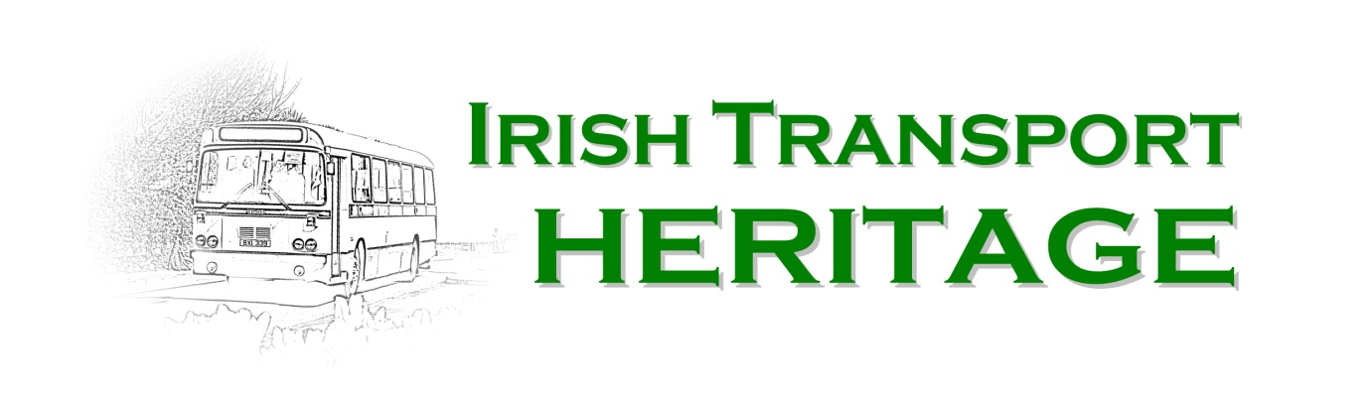
Name:_________________________________________________
Address: _______________________________________________

________________________________________________

Post Town: _____________________________________________

Post Code: ______________________________________________

I enclose a Cheque/PO/Cash £_______________________________

Signature:_______________________________________________
Dear Member
Corgi has recently announced its releases for January to June 2014. One model which should be of particular interest to ITH members is a Volvo B7RLE/Wright Eclipse 2 in Bus Eireann livery, and it will be available from Irish Transport Heritage. It comes with a choice of two destinations (OM46702A - 215 BLARNEY and OM46702B - 203 FARRANREE VIA PARKLANDS), so please make sure you order the correct model when placing your order.
Photograph: (c) Hornby Ltd
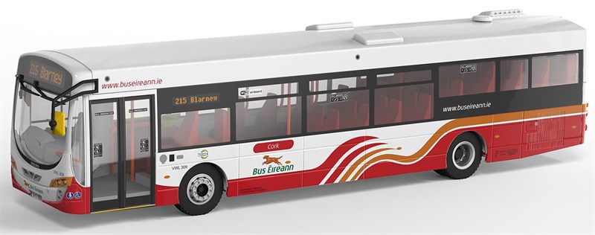
If you would like to add either or both of these models to your collection, they will cost you £31.00 each, RRP £36.99, (plus £5.00 postage for one model (multiple orders/outside UK will be more, but please enquire)). Get your Bus Eireann Volvo B7RLE/Wright Eclipse 2 by filling out the order form and returning it, no later than Saturday 26th October, to the address below:
Irish Transport Heritage,
c/o 3 Clarkhill Road,
Castlewellan,
Co Down,
BT31 9JA
Payment can be made by cheque, cash or postal order only. Please make cheques/postal orders payable to IRISH TRANSPORT HERITAGE. DO NOT SEND CASH BY POST. Orders will not be accepted without payment. You can, of course, avoid the postage charges, over which we have no control, by collecting your order at an ITH meeting or outing. For delivery enquiries, or if you need more information, please contact irishtransportheritage@outlook.com. We can also supply most currently available models so feel free to contact us for prices.
Bus Eireann Volvo Wrights Eclipse.

Name:_________________________________________________

Address: _______________________________________________

________________________________________________

Post Town: _____________________________________________

Post Code: ______________________________________________

I enclose a Cheque/PO/Cash £_______________________________

Model collect or post: ____________________
Model A or B ______________

